Shabbos Stories
For yom tov pesach 5784
Volume 15, Issue 35 15-22 Nisan 5784/April 23-30, 2024
Printed L’illuy nishmas Nechama bas R’ Noach, a”h
For a free subscription, please forward your request to keren18@juno.com
Past emails can be found on the website – ShabbosStories.com

The Last Clean Cup
From the Desk of Yerachmiel Tilles

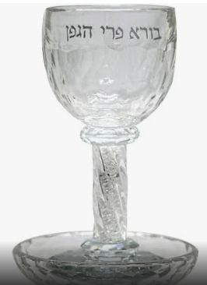
Every year, in honor of Passover, members of the Baal Shem Tov’s household purchased a large quantity of new cups to be used for the duration of the holiday. Of course, the glasses that were to be used would first be immersed in a mikvah , following Jewish law.
The glasses came in a variety of shapes and sizes. And in classic Jewish legal sources, there is a system for measuring liquids, with specific names for the various amounts. In the Baal Shem Tov’s home, the glasses were referred to by the Jewish name for the amount of liquid they were able to contain. Thus, a glass that contained 3-4 ounces was called a revi’it glass, etc.
Before Passover, the Baal Shem Tov would look through the glasses and instruct which cups could be set upon the table and which should be set aside. He provided no reasons for his directives, but everyone understood that his reasoning was a product of his exalted spiritual level.
Thus passed the first seven days of Passover.
Then, the final meal on Passover, [1] known as “Moshiach’s meal,” was special. It was open to the public; everyone who passed through the sage’s door was free to enter and partake of the festivities.
One year, before Moshiach’s meal began, the Baal Shem Tov instructed that a certain cup be removed from the table because it had not been immersed. After, during the meal, a newcomer entered and asked for some wine. “Sorry,” he was told, “but there are no more clean cups.”

Pointing to the Cup that Had Been Set Aside
“What do you mean?” he asked with surprise, pointing to the cup that had been set aside. “I see a clean cup right over here that no one is using!”
“Oh,” he was told, “that cup has not been immersed in the mikvah and must not be used.”
“It doesn’t matter,” he replied dismissively, reaching for the cup.
At that point, the Baal Shem Tov, who had been silent until this point, interrupted. “He just testified about himself,” he declared in a sad tone.
The words were mysterious to everyone aside from the man himself. Hearing the rebbe’s caring words of rebuke, he admitted his shortcoming. It was true. He and his wife were not particular about the laws of family purity, which require a previously menstruant woman to immerse in a mikvah before being intimate with her husband.
Inspired by this revelation of the Baal Shem Tov’s extraordinary holiness, the couple resolved to mend their ways.
~~~~~~~~~~~~~~~~~~~
Source: Adapted by Yerachmiel Tilles from the translation on Chabad.org, based on the writings & talks of Rabbi Yosef - Yitzchak Schneersohn , the sixth Lubavitcher Rebbe , as printed in Sefer Hasichot, 5702.
Biographical note: Rabbi Yisrael ben Eliezer [of blessed memory: 18 Elul 5458 - 6 Sivan 5520 (Aug. 1698 - May 1760 C.E.)], the Baal Shem Tov [“Master of the Good Name”—often referred to as “the Besht” for short], a unique and seminal figure in Jewish history, revealed his identity as an exceptionally holy person, on his 36th birthday, 18 Elul 5494 (1734 C.E.), and made the until-then underground Chasidic movement public. He wrote no books, although many works claim to contain his teachings. One available in English is the excellent annotated translation of Tzava'at Harivash, published by Kehos.
Connection – seasonal: Preparations for Passover.
[1] At the end of the 7th day in Israel; at the end of the appended 8th day outside of Israel.
Reprinted from the Pesach 5783/2022 email of KabbalaOnline.org, a project of Ascent of Safed.
A Unique Pesach Seder
By Rabbi Yoni Schwartz

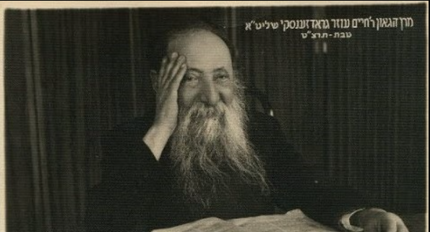

Rav Chaim Ozer Grodzensky, the chief rabbi of Vilna, had legendary Ahavas Yisroel (Loving Jews). One year, three weeks before Pesach, the non-religious leader of the Jewish socialist organization at the University of Vilna received a message from him. The message stated that the Rav would like to meet him. Curious, the young Jew began to make his way over.
As he arrived, the Rav warmly greeted him and offered him cake and tea. He then explained that there are about 3,000 non-religious Jews in his organization and he would like to do a Pesach seder for them. The Rav added that if he does a Seder, nobody will show up, however, if the leader of their organization does a Seder, many will come.
Rav Chaim Ozer was even willing to cover the costs of the Matzah, Marror, and four cups of wine for each person, no matter how large the crowd. Being willing to pay for Matzah (which is pretty expensive), Marror, and that much wine for thousands of students is accepting a major financial burden.
Nevertheless, for the Rav, to remind thousands of their Jewish identity and their collective history, it was all worth it. Indeed, the leader of the group made the Seder and thousands of Jews attended with the event being a massive success.
Comment: This week’s parsha begins our story as a free nation and is a pivotal moment in the formation of our collective Jewish identity. Hashem fights for the freedom of a powerless group of slaves against the world’s most powerful empire. Every Shabbos during Kiddush we say, “a remembrance of the exodus from Egypt.” Each week we “remember” because, although learning forms our character, remembering forms our identity.
Our identity is only as strong as our memory. That is why many Jews go off the derech (veer off the Torah path). They lose their Jewish identity because nobody has ever reminded them of their Jewish story. What we remember shapes our destiny and Rav Chaim Ozer wanted to make sure that each Jew remembers who he/she is: a child of Hashem.

Reprinted from the Parshas Bo 5784 edition of Torah Sweets edited by Mendel Berlin.
The Reward of a
Pesach Mitzvah

There’s an amazing story in Rabbi David Ashear’s latest “Living Emunah 4” book told by Rabbi Yitzchak Shlomo Unger of' Bnei Brak, which shows how much Hashem loves us when we go above and beyond our limits to follow the Torah and fulfill the mitzvot Hashem gave us!
One morning, one of Rabbi Unger’s congregants, whom we'll call Yosef, came to him all shaken up about a dream he had that night and related the following: Thirty years earlier, Yosef had been in a labor camp in Auschwitz. Toward the end of the war, Moshe was assigned to his barracks, who appeared to be very pious, the son of an illustrious Rabbi, who was following in his father's footsteps.

Moshe Proposes a Deal with Yosef
Moshe had just been separated from his wife and children, who were taken to the gas chambers. Despite what he went through, he clung to Hashem, using his spare moments to learn and pray, and gave chizuk in Emunah to the other inmates. As the Yom Tov of Pesach was approaching, Moshe turned to Yosef' and said, "I managed to save up enough flour to bake two k'zeisot--- measures of matzah. If you go bake them, I'll give you one k'zayit, and we'll each do the mitzvah properly."

Yosef accepted and he managed to bake the matzot, but before he could make it back to the barracks, a Nazi caught him and started to viciously beat him. The matzah fell out of his jacket. The Nazi saw it, smashed it, and struck him again more forcefully. When the brute was finally done, Yosef was bloody and sore. He gathered up whatever fragments he could and managed to salvage one k’zayit worth of matzah.
The question now arose. Who should eat it? Moshe, who owned the flour, or Yosef, who look the beating for baking the matzah? The men came to the agreement that Moshe, who owned the flour, would eat the k’zayit, but Yosef, who took the beating, would get the reward in Heaven for it. The next day, Moshe sang Hallel as they labored. He sang a little too loudly for one of the Nazis, who got angry and killed him on the spot.

Yosef Had a Strange Dream 30 Years Later
Yosef managed to survive the war and rebuilt his life, eventually getting married and having children and grandchildren. Now, 30 years after the war ended, he had a strange dream in which he saw his friend Moshe, his face was shining. "Remember when I ate the matzah in the labor camp and gave you the reward.?" he said. "Please, give that reward back to me, I need it. Yosef replied in the dream, "I risked my life for that matzah. I took a beating for it. Why should I give it up'?"
And with that, Moshe left his dream...

Asks Rabbi Unger What Should He Do
In the morning, Yosef remembered the dream and was very disturbed. That's when he came to Rabbi Unger and told him what happened. He asked the Rabbi if he should give up the reward. Rabbi Unger said, "I don't know how to answer this question, but I will send you to the Rebbe of Machnovka, who will be able to help you."
Yosef presented his dilemma to the Rebbe, and the Rebbe told him, "It is only proper that you give him the reward." Yosef then asked, "Why is that proper? I suffered for it." The Rebbe replied, "Your friend Moshe can no longer do mitzvot, nor can his children, who also perished in the war. You, baruch Hashem, are alive, with a family. You can still fulfill mitzvot. You will also receive the rewards for all your children doing mitzvot, as well as their children, until the end of time. You can still put on tefillin; you can pray; you can make berachot; you can keep Shabbat and you can eat a k'zayit of matzah. Your potential is endless.
"Moshe, on the other hand, can't do anything. He doesn't have people doing mitzvot for him. Isn't it proper that you should at least give him the mitzvah that he did?"

Yosef agreed. The Rebbe then told him, "I want you to go to my shul late tonight, when nobody's there. Stand in front of the aron kodesh. Think about all you went through to bake that matzah, and the beating that you took. And only then, wholeheartedly, say that you give all that up to Moshe.” Yosef did as he was told, and that night a beaming Moshe came to him in a dream and thanked him for what he had done.

The Lesson to Be Learned
The next morning, Yosef went to the Rebbe and told him what happened. The Rebbe replied, "I want you to learn a lesson from this. Moshe was a very pious man, the son of a great tzaddik. He grew up religious and spent all his time in avodat Hashem, even in the labor camp. After he lost his wife and children, he still kept his cmunah and never stopped learning and praying. He died while saying Hallel, al kiddush Hashem. Chazal (pesachim 50a) tell us that anyone who dies al kiddush Hashem is elevated to a place in Gan Eden that no one else could reach. And still, after all that, years later, he is still yearning to go higher in Gan Eden. And for that, he needed the merit of this difficult mitzvah."
We can't imagine what mitzvot do for us. And when we do them in the face of difficulties, they become infinitely greater. How fortunate are we that we have opportunities to fulfill mitzvot all the time!

Helping Our Children and Grandchildren
to Link to the Generations Past
May we all have uplifting Seder nights, and May we be able to convey the story of our redemption to our children and grandchildren so that they may grow up and convey it to their children in order to link the generations. May we also learn from the story the importance of our mitzvot and how much they help to elevate the Neshamot of our ancestors in Olam Habah as we look forward to the coming of the Mashiach in our days! Amen!

Reprinted from the 5779/2019 email of Jack E. Rahmey based on the Torah teachings of Rabbi Amram Sananes.

Kriyas Yam Suf
By Rabbi Nachman Zakon

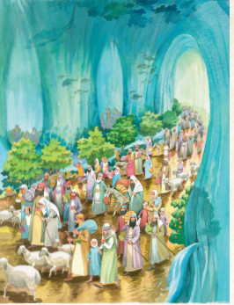
Illustrated by Tova Katz

As all the Jews watched, the greatest miracle they had ever seen happened before their eyes. The waters of the sea split! With the Egyptian army chasing after them, wanting to capture or kill them, the Jews raced into the sea, which then became dry land! Many, many miracles happened on that night.
Twelve Roads
The sea didn’t just split in half. The raging sea split into twelve separate paths. The waters of the sea rose up to become frozen solid walls. Each shevet passed through its own pathway. As the Jews walked on their roads, Hashem made roofs over them. They didn’t have to step into the wet mud of the sea bed. Instead, there was a dry floor under their feet.
Not only was it dry, it was beautiful, since it dried like floor tiles. And Hashem made a roof over their heads. The walls were see-through. That way people could see their friends and relatives from different shevatim, walking safely across what had been the sea.

Water Fountains and Fruit Trees
Imagine: The Jews are walking through the dried sea, and a little child starts to cry. He’s thirsty! His mother touches the wall — and out comes sweet water. And what about food? There’s plenty to eat. The Jews walking through the tunnels see fruit trees miraculously growing out of the ground. There’s even some grass growing for the animals to munch on.

Reprinted from the At the ArtScroll Shabbos Table edition for Parshas Beshallach. Excerpted from the ArtScroll book – “The Weekly Parashah – Sefer Shemos.”

“We are Here!”

During World War II, a group of Jews from the town of Chust sat huddled in a dark basement on the night of Pesach, to celebrate the Pesach Seder. Wanting to encourage his followers, the Chuster Rav, Rav Yehoshua Greenwald, OB”M, addressed the group.
“We read in the Haggadah, ‘Now we are here; next year in Eretz Yisrael.’ What does that mean by “we are here’? Of course, we are here – where else would we be? Why does he need to make such a statement?”
The tortured and exhausted people awaited his response in silence. Rabbi Greenwald continued with emotion. “Perhaps the Haggadah is telling us that if a Jew despairs because of the bitter lot which had befallen our people, he should realize that at least ‘we are here’ – we are still alive and able to celebrate the Pesach Seder in this World. Hashem, in His Mercy, has preserved us thus far. Surely, He will bring us to freedom next year in Eretz Yisrael. So do not give up hope!” (Story from the Torah Tavlin Haggadah).
Pesach, our time of freedom this year has fallen at an extremely difficult period, a period where we are not exactly free.
However, we must keep in mind the message of the Haggadah. If we are here – alive – and we have made it to the Seder somewhere, we must take consolation in even that privilege these days. Jews have survived for millennia and Hashem has the end-game in mind for our Redemption, may it be very soon!

Reprinted from the Pesach 5780 email of Torah Sweets edited by Mendel Berlin.

The Healing Power of Matzah

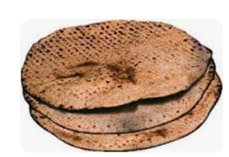
Reb Tzvi Kintzlicher zt’l was rav of Seban, Romania (until he moved to Yerushalayim in 5709). Due to severe stomach pains, he traveled to the medical center in Klausenberg, where the doctors urged him to have immediate surgery. Reb Kintzlicher realized that if they would operate on him right then, he wouldn’t be home in time for Pesach.
So, he told them that he wants to go home, and will return right after Pesach. The doctors tried to persuade him to remain, but when they saw he was adamant, they told him to be careful to only eat light foods, such as eggs, milk, and fruits.
Reb Kintzlicher was planning to keep these rules, but at the Seder he decided to eat matzah soaked in milk. While eating the matzah he felt something positive happening to his stomach. He ate matzah on the second night of Pesach too, and when he finished eating that kezayis, he didn’t have any stomach pains at all.
On Shabbos after Pesach, he stood up on the bimah of his beis medresh and gravely told his congregation that he was leaving for a serious operation. "Pray for me, because who knows if I will survive…"
When he returned to Klausenberg, the doctors examined him, and saw that he was better. “Which doctor did you go to?” they asked, stunned. He told them that he was cured with the mitzvah of eating matzah, the healing food.” One of the doctors said, "A great miracle happened to you. But I've always known and I've seen it several times: everything we doctors know is like nothing when Hashem desires differently."

Reprinted from the Pesach 5779 email of Torah Wellsprings based on the Torah insights of Rabbi Elimelech Biderman.

‘If You Make Mine
Happy, Then I Will
Make Yours Happy’
By M.K.

True, this story happened three years ago on Erev Pesach, but now that I am a steady reader of ‘Tiv HaHashgacha’ I wanted to publicize the story to the masses. Erev Pesach the expenses are many, but the budget is tight. Out of fear, I could not bring myself to check the balance in my bank account.
In my line of work, I do not know when money will come in as the income is not set as I am self-employed. In the middle of my running around, my cell phone rings. On the other end is my wife who announces that this year we have to buy a new microwave oven for Pesach.
It is known that the expenses for the holiday are on the account of the Creator and a Jewish man is obligated to make his wife happy. And so, I agreed with my wife that in the evening we would go to Talpiyot together and look for a microwave on sale. We went out and found one for 400 shekels.
When I took out my credit card I said some Tehillim that the purchase should go through and I not suffer the embarrassment of a declined card, and after a few seconds, Baruch Hashem, the sale went through.
After the successful shopping, I felt weak from hunger which I tried to hide from my wife until she said with all the Pesach preparations she had forgotten to eat and was feeling faint. Since this came from her, I immediately took her to a restaurant where my friend is the mashgiach and we sat down to eat.
After, I asked my wife to go ahead of me to the car while I pay for the meal. She did not know that the reason I sent her ahead was because I was afraid the credit card would not work which would cause an unpleasant situation. My wife got to the car and with a Tefillah, the card worked. I had already made up with the mashgiach that if the card did not work, I would come back with the money another time.

I left the restaurant and thanked Hashem for all His kindnesses, for the microwave, for the meal and a request to cover all the expenses. On the way back to the car, instead of walking on the sidewalk, I walked on the path next to the sidewalk, suddenly, I saw a 200 shekel note on the path. I gladly picked up the note and thanked Hashem for the gift. But with the thanks, I saw another 200 shekels note which I picked up close to the car. I sat in the car and told my wife that Hashem had just paid me for the microwave. She was quite pleased and we headed back home.
We had gone a short while when I turned around and my wife asked: “Where are we going?” I replied: “If Hashem sent us a microwave, perhaps He also sent us 200 shekels for the restaurant. She smiled but I stuck to it and I began to look and I found another note. I kept looking but I did not find any more money. I got back in the car and thanked Hashem for paying for everything.
From then on, every Erev Pesach I tell the story and strengthen faith in Hashem Who can do everything without limits and makes shopping easy without arguments as long as we are with simcha, there is bracha!!!

Reprinted from the Parshas Metzora 5779 edition of Tiv Hakehila.

The Reward of the
Stubborn Innkeeper

L’Maaseh
Rav Avraham J. Twerski writes an amazing story. Raphael Dubzinsky was a pious Jew who lived in a village in Poland, and like so many of his countrymen who were barred from living in the larger cities and from pursuing various types of livelihood, Raphael operated an inn which he rented from the local Poritz, landlord.
Raphael was known for his honesty and was respected and loved by all— both Jew and Gentile alike. Raphael and his wife were content, but their happiness was not complete because they weren’t yet Bentched with children.
One day, a new priest came to the village, and he was a hateful anti-Semite, and the fact that Raphael was popular annoyed him to no end. The priest issued an edict that none of his parishioners were allowed to visit Raphael’s inn and do business with him, but since the inn had been a gathering place for these people for years, the edict was not listened to.
The priest put pressure on the Poritz to withdraw Raphael’s lease on the inn, but that also did not work. The priest finally came up with a plan. He knew that Raphael sold his entire supply of beer and liquor to a non-Jew every Pesach, so the priest issued an edict that no one was permitted to buy Chometz from the Jews, under severe threat of punishment.
When Pesach arrived and Raphael saw that no one wished to buy his Chametz, he opened wide the doors to his inn and made a public announcement: “I declare all my beer and liquor ownerless! Whoever wishes may come in and take it!” He and his wife then left to spend Pesach with relatives, and although he knew that he would now be suffering a great loss from his business, Raphael rejoiced during the festival.
The Vicious Dogs Blocked Us
From Enjoying the Free Drinks
When he returned home, Raphael asked the first person he met whether everyone had enjoyed all the free drinks. The man answered, “What do you mean enjoyed free drinks? We couldn’t even get close to your inn with those vicious dogs you had left guarding it!”
Raphael did not know what they were talking about as he didn’t own any dogs, but when he came to the inn, he saw two vicious looking dogs in front of the entrance. When they saw him, the dogs gently approached him, sniffed him, and then ran off.
Raphael realized that Hashem had sent the dogs to protect him from losing all his beer and liquor. He considered his situation and realized he may have a problem. If his Chometz had been guarded and remained in his possession over Pesach, it was forbidden to derive any benefit from it.
Raphael began opening the spouts of the barrels and began to dispose of the beer and liquor, but his wife screamed at him, “What are you doing?! You did what you were supposed to do and made everything Hefker, ownerless. You are now allowed to use it and sell it! Ask the Rabbi!”

The Husband Asks the Rav His Wife’s Question
Raphael asked the Rav, and he ruled that the wife was indeed right. When Raphael opened the doors and left his inn open to all, declaring publicly that all who wished were free to help themselves, he had indeed abandoned ownership of the Chometz. The fact that Hashem had miraculously protected him, did not change anything, and he was permitted to reclaim his goods.
However, Raphael was not comfortable with the ruling. He said, “The Chometz was in my inn over Pesach, and even though it is Halachically permitted, I still do not wish to benefit from it,” and he poured his entire stock down the drain.
His wife went weeping to the Rav to tell him what happened. Through tears she said, “Now we are both childless and penniless!” The Rabbi said to her, “In the merit of your husband’s intense devotion to Torah, it will be a Zechus for you to have a child who will illuminate the entire world!” That year, this woman gave birth to a son, who later became the Chasidic master, Rav Abraham of Czechanov!”
Reprinted from the Pesach 5779 email of Torah U’Tefilah compiled by Rabbi Yehuda Winzelberg.
The Splitting of Red
Sea (Sea of Reeds)

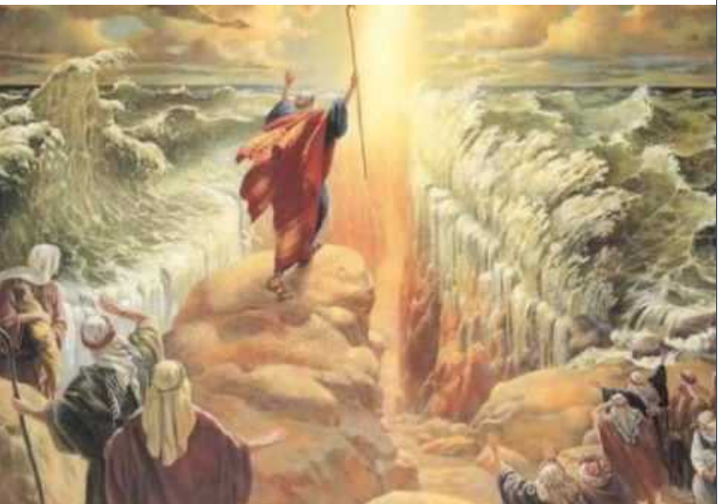

Wishing Everyone a Kosher V’Sameach Pesach

